HOW TO ACCESS TO THE WIC SUPERVISION
SUMMARY :
This document explains the different steps in order to access to the WIC Supervision from outside and inside CERN.
DOCUMENT PREPARED BY : | DOCUMENT TO BE VERIFIED BY : | DOCUMENT TO BE APPROUVED BY :
Y.Bastian | C.Chervet  A.Antoine | R.Mompo

SUIVI DES MODIFICATIONS
Nº DE RÉV. | DATE | PAGES | DESCRIPTIONS DES MODIFICATIONS
0.0 | 2017-04-07 | n

TABLE DES MATIÈRES
1. ACCES FROM OUTSIDE CERN 4
2. ACCES FROM INSIDE CERN 4

ACCES FROM OUTSIDE CERN

Here the different steps to access to the WIC Supervision from home for example :
- In the Windows Start Menu, click on “Remote Desktop Connection”, choose “cerntsnew”, and press “Connect”
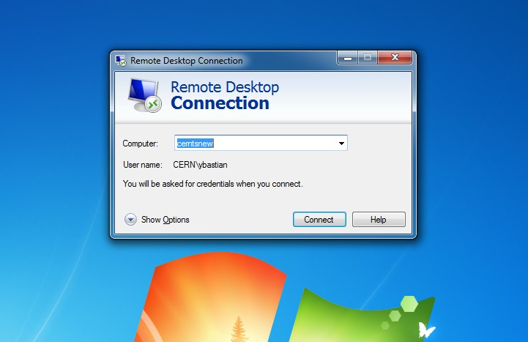
- Then fill boxes with your CERN login and password and press “OK”. Maybe the windows here below will appear. You can press “Yes”. Of course, if don’t want to do this for each connection you can tick the box “ Don’t ask me again for connections to this computer”
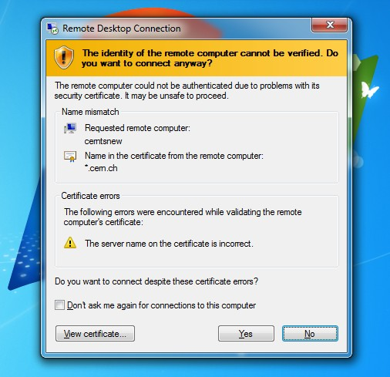

- When you’ll be connected on cerntsnew machine you have to ask again a “Remote Desktop Connection” for “cerntslb06”, with login, password,…
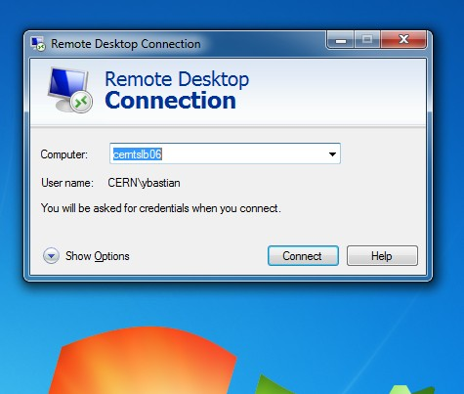

- On “cerntslb06” click on “Start” and then “Run…”
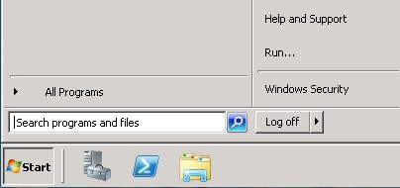

- In the “Run” window enter this command :
jws http://abwww.cern.ch/ap/dist/ccm/PRO/ccm.jnlp
And press “OK”

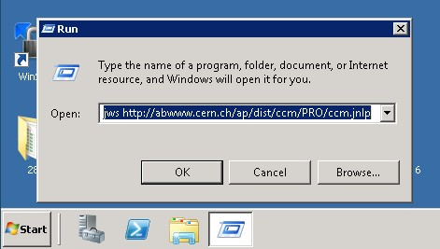

- After few seconds, the window here below will appear. Go down and double click on “UNICRYO”
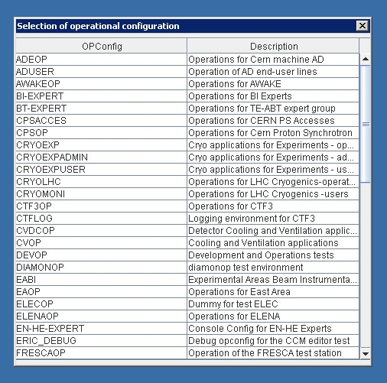

- At the top of the screen, you’ll see this toolbar.
- Then choose the “WIC” Menu, and select the WIC you want to check.
For example here, the “WIC BOOSTER”.
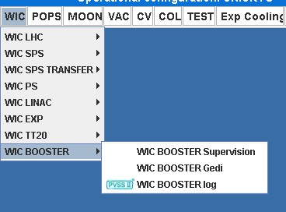

ACCES FROM INSIDE CERN
The way to access to the WIC Supersion is the same but you don’t need to pass through “cerntsnew”. So you can follow the previous steps by starting in point 3).

